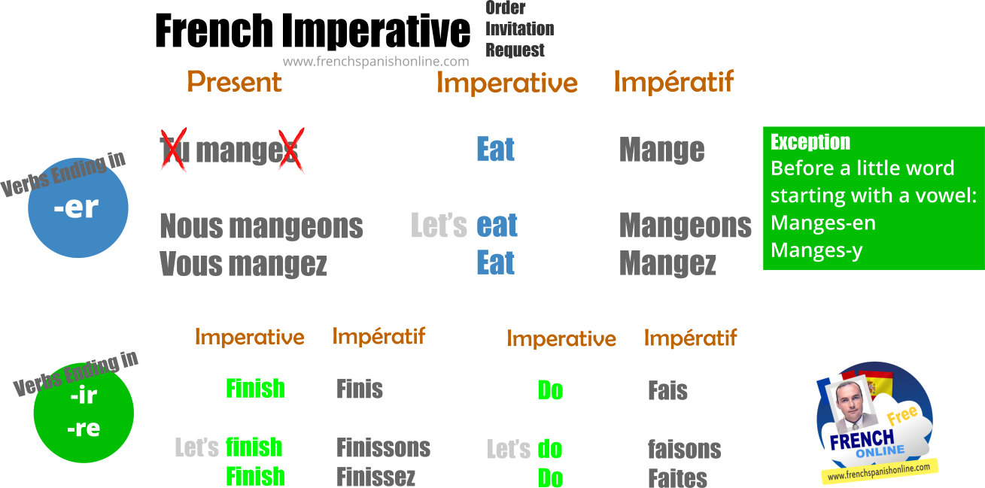

With this mood you express an intention to influence the behaviour of someone else:
- Order: Go, go to your bed: Order
- Invitation: Let’s go to the park: Invitation
- Request: Give me your pen: Request

